**Homework 4**

Remember that your programs must read the data from the text files exactly as they appear. You may not edit the text files to make them more convenient for SAS. Turn in the code, log file and output. If any of these 3 items is missing then you will not be graded for that question. Use the snipping tool instead of screen shots and make sure the font is large enough for me to read.

1. Refer to the SOCCER dataset. Write a SAS program which creates a SAS dataset and writes each player’s name and jersey number to a text file called SOCCDATA.TXT on your hard drive or USB. The text file should look like this:

Danielle Bass wears Number 11 .

Erin Baxter wears Number 23 .

Keisha Bell wears Number 5 .

Christie Brady wears Number 8 .

Etc.

Turn in a copy of the SAS program and a printout of the file SOCCDATA.TXT. Make sure that your program reads jersey number 00 correctly.

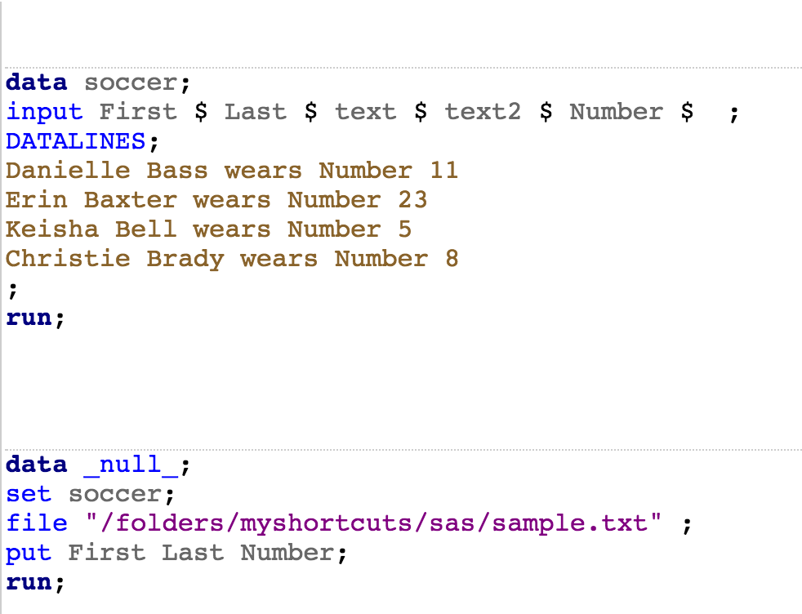

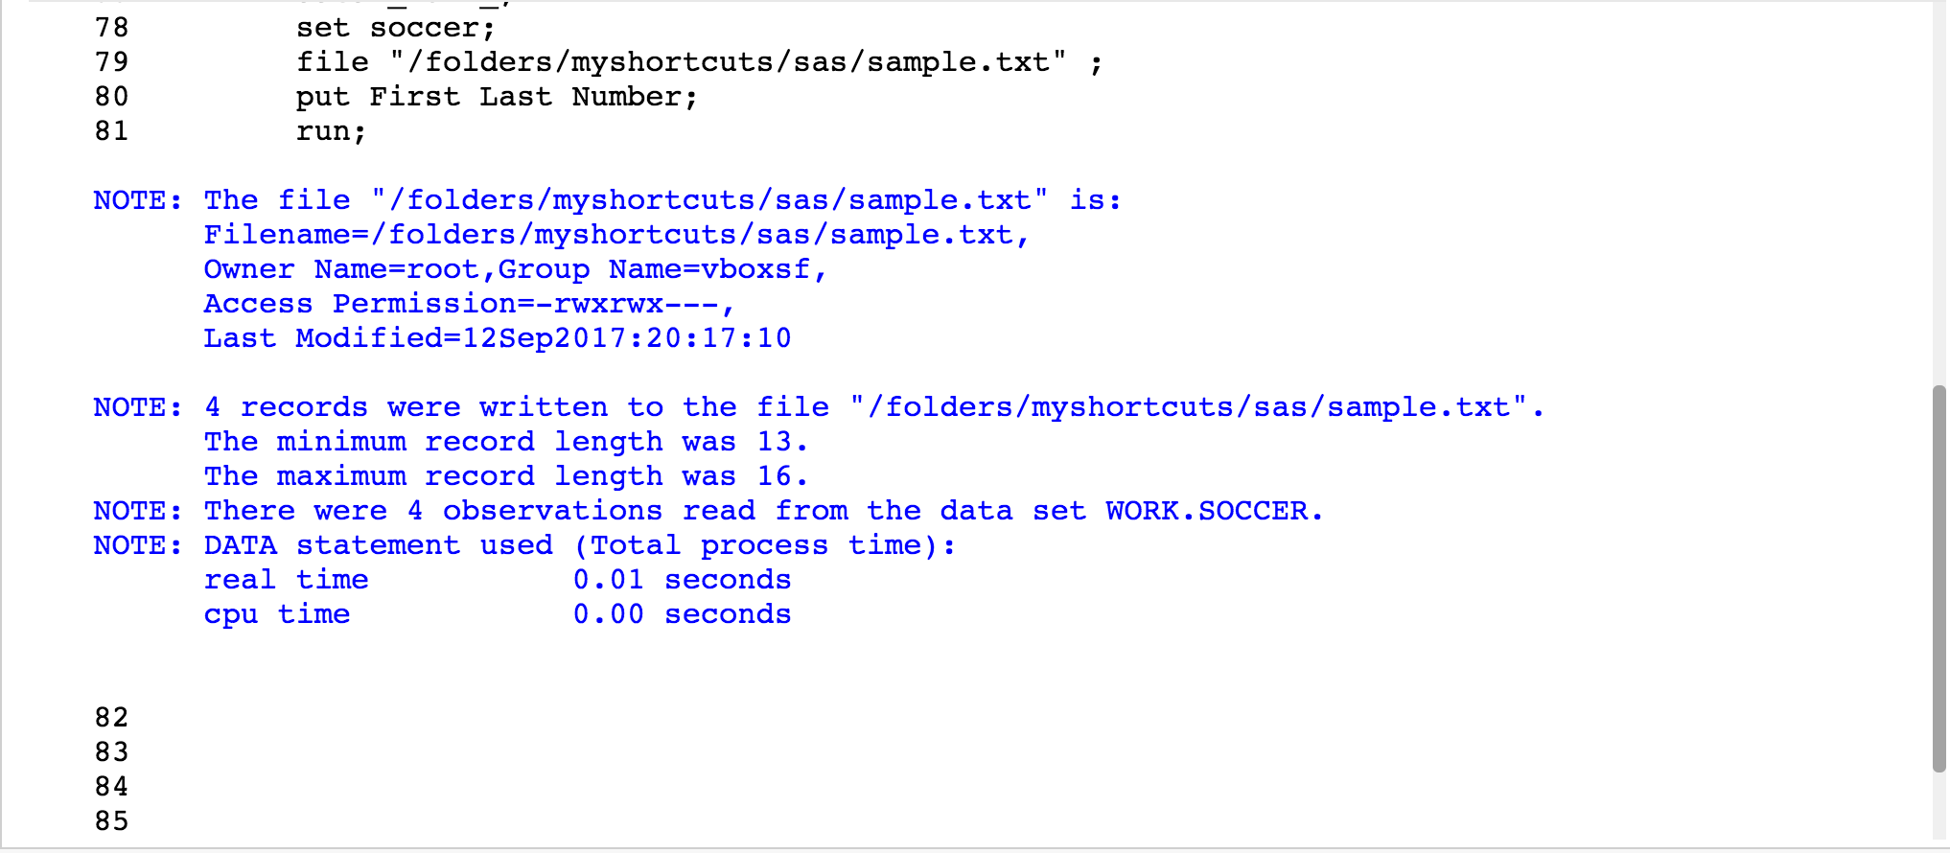

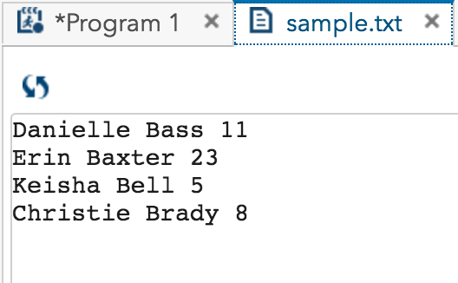

4.. Run the following program to create a SAS data set called Colors

**data** colors;

input Color : $1. @@;

datalines;

R R B G Y Y . . B G R B G Y P O O V V B

;

Use a format to group the colors as follows:

R, G, B = Group 1

Y, O = Group 2

Missing = Not Given

All others = Group 3

Use PROC FREQ to list the frequencies of the color groups.

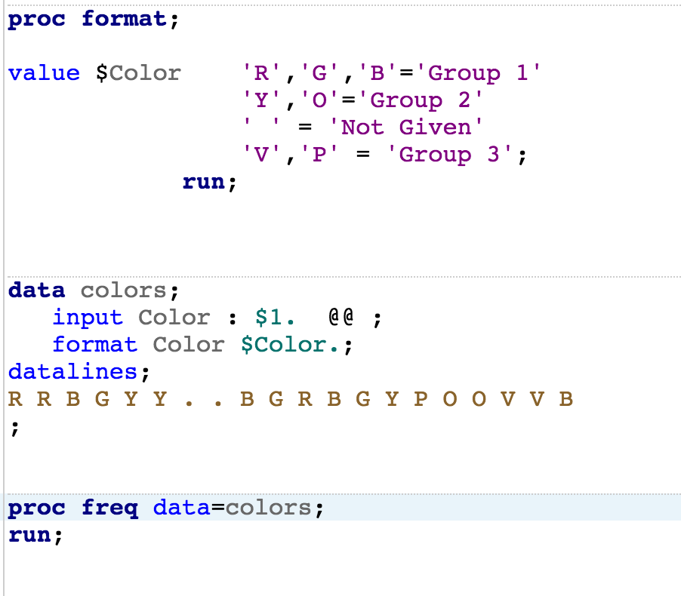

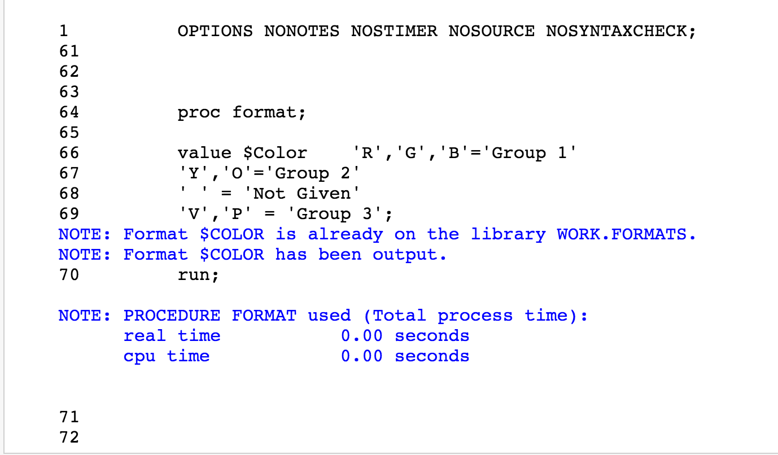

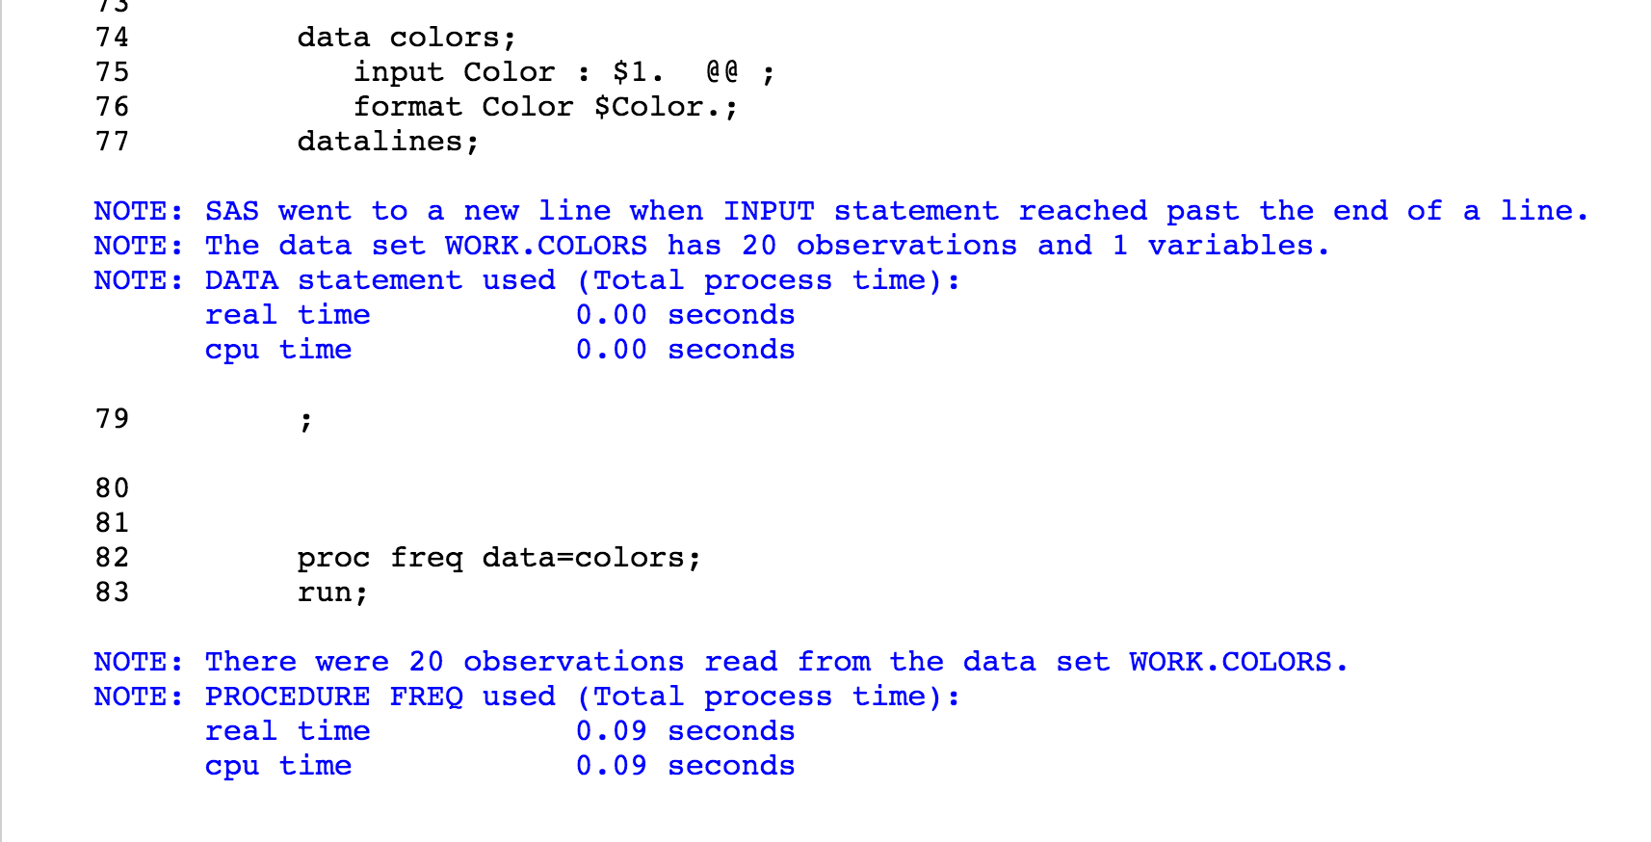

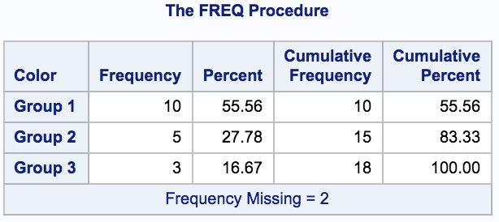

5. Write the necessary statements to make three permanent formats in a library of your choice. Use the FMTLIB option to list each of these formats. The formats are defined as follows:

YESNO 1=Yes, 0=No

$YESNO Y=Yes, N=No

$Gender M=Male, F=Female

Age20yr low-20 = 1, 21-40=2, 41-60=3, 61-80=4, 81-high=5.

